**SHRI VAISHNAV VIDYAPEETH VISHWAVIDYALAYA**

**SHRI VAISHNAV INSTITUTE OF INFROMATION TECHNOLOGY**

**Department of Computer Science and Engineering**



**Session: July-Dec 2022**

**PRACTICAL FILE**

**Object Oriented Analysis and Design**

**BTIT 604**

**Submitted by: Nikhil Saxena**

**Enrollment No.: 19100BTCSES05385**

**Section: F**

**Guided by: Prof. Shweta Pandey**

**INDEX**

|  |  |  |
| --- | --- | --- |
| **Experiment No.** | **Objective** | **Page No.** |
| 1. | How to write a Problem Statement | 3 |
| 2. | Perform the system analysis: Requirement analysis, SRS. | 5 |
| 3. | Perform the function-oriented diagram: DFD and Structured chart. | 27 |
| 4. | Perform the user’s view analysis: Use case diagram. | 30 |
| 5. | Draw the structural view diagram: Class diagram, object diagram. | 31 |
|  |  |  |
|  |  |  |
|  |  |  |
|  |  |  |
|  |  |  |

**Experiment: 01**

**Aim:** How to write a Problem Statement.

**How to write Problem Statement:**

**Step 1: Contextualize the problem**

The problem statement should frame your research problem, giving some background on what is already known.

**Practical research problems**

For practical research, focus on the concrete details of the situation:

* Where and when does the problem arise?
* Who does the problem affect?
* What attempts have been made to solve the problem?

**Theoretical research problems**

For theoretical research, think about the scientific, social, geographical and/or historical background:

* What is already known about the problem?
* Is the problem limited to a certain time period or geographical area?
* How has the problem been defined and debated in the scholarly literature?

**Step 2: Show why it matters**

The problem statement should also address the relevance of the research. Why is it important that the problem is addressed?

Don’t worry, this doesn’t mean you have to do something ground breaking or world-changing. It’s more important that the problem is researchable, feasible, and clearly addresses a relevant issue in your field.

**Practical research problems**

Practical research is directly relevant to a specific problem that affects an organization, institution, social group, or society more broadly. To make it clear why your research problem matters, you can ask yourself:

* What will happen if the problem is not solved?
* Who will feel the consequences?
* Does the problem have wider relevance? Are similar issues found in other contexts?

**Theoretical research problems**

Sometimes theoretical issues have clear practical consequences, but sometimes their relevance is less immediately obvious. To identify why the problem matters, ask:

* How will resolving the problem advance understanding of the topic?
* What benefits will it have for future research?
* Does the problem have direct or indirect consequences for society?

**Step 3: Set your aims and objectives**

Finally, the problem statement should frame how you intend to address the problem. Your goal here should not be to find a conclusive solution, but rather to propose more effective approaches to tackling or understanding it.

The research aim is the overall purpose of your research. It is generally written in the infinitive form:

* The aim of this study is to **determine**…
* This project aims to **explore**…
* This research aims to **investigate**…

The research objectives are the concrete steps you will take to achieve the aim:

* Qualitative methods will be used to **identify**…
* This work will use surveys to **collect**…
* Using statistical analysis, the research will **measure**…

**Problem Statement for Online Voting System:**

Online voting has been an active area of research in the recent years, efforts to develop real-world solutions have just begun posing several new challenges. The use of insecure Internet, well documented cases of incorrect implementations and the resulting security Breaches have been reported recently. These challenges and concerns have to be resolved in order to create public trust in online voting.

The present voting system in the country has proved inefficient as the voters’ registration process is slow, the manual collation of results takes time and gives room for result manipulation, also the inaccessible nature of election venues which includes the long distances to be covered by voters’ to their registered location increases voters’ apathy towards the election processes, and finally the issues of ballot box snatching and damage and other election violence and issues associated with the traditional ballot paper voting all defiles the purpose of voting in election process as a formal process of expressing individual opinions for or against some motion.

The existing manual Voting system consumes more time for Vote Casting. Voter has to wait for vote polling station to vote for a candidate. The election officers have to authenticate the voter, ensure that the voter can vote in this booth then check voter ID present in voters list of booths those are information will be present then the voter can vote in that booth. The voter had to stand in queues to cast his vote. All the work is done in paper ballot so it is very hard to locate a particular candidate; some voters may cast their votes for wrong candidates. To overcome all these problems, we need to implement a web application, which is helpful for Voting from anywhere.

The main objective of this study is an important step towards streamlining this effort is to develop a framework and identify necessary properties that a secure and trusted online voting system must satisfy to reduce discovery redundancy. Such a framework will allow us to evaluate as well as compare the merits of existing and future candidate online voting schemes.

Online Voting System provides the online registration form for the users before voting and makes the users to cast their vote online. The system is to be developed with high security and user friendly.

Aim: In the quest to design a successful system to tackle the issues stated in the problem statement, the aim of this project is to design and implement a low-cost automated online voting system.

Objective: The objective of the system is a replacement of the traditional system that is in existence. This smart system reduces the time for voting and also the system is reliable, and faster. In this system the voter username and password will be sent through SMS. The voter cast their vote by entering the confirmation OTP sent to his/her mobile number. Database maintained by this system usually contains the Voters information, Candidate information, the final Result of total votes.

**Experiment: 02**

**Aim:** Perform the system analysis: Requirement analysis, SRS.

**ONLINE VOTING SYSTEM**

**INTRODUCTION**

**1.1 Background of Study:**

In every democratic setting with persons of differing and inconsistent opinions, decisions must be made between several options. This happens in business environment, educational environment, social organizations, and mostly in governance. One of the ways of making such a decision is through voting. Voting is a formal process of expressing individual opinions for or against some motion. In the governance sector of many organizations this process is always used as a means of selecting or electing a leader. One of the key areas where voting is applied is in election. Election is the formal process of selecting a person for public office or of accepting or rejecting a political proposition by voting.

**1.2 Problem Statement**

The present voting system in the country has proved inefficient as the voters’ registration process is slow, the manual collation of results takes time and gives room for result manipulation, also the inaccessible nature of election venues which includes the long distances to be covered by voters’ to their registered location increases voters’ apathy towards the election processes, and finally the issues of ballot box snatching and damage and other election violence and issues associated with the traditional ballot paper voting all defiles the purpose of voting in election process as a formal process of expressing individual opinions for or against some motion.

The existing manual Voting system consumes more time for Vote Casting. Voter has to wait for vote polling station to vote for a candidate. The election officers has to authenticate the voter, ensure that the voter can vote in this booth then check voter ID present in voters list of booth those are information will be present then the voter can vote in that booth. The voter had to stand in queues to cast his vote. All the work is done in paper ballot so it is very hard to locate a particular candidate; some voters may cast their votes for wrong candidates. To overcome all these problems, we need to implement a web application, which is helpful for Voting from anywhere.

**OBJECTIVE**

**2.1 Aim:**

In the quest to design a successful system to tackle the issues stated in the problem statement, the aim of this project is to design and implement a low-cost automated online voting system.

**2.2 Objective:**

The objective of the system is a replacement of the traditional system that is in existence. This smart system reduces the time for voting and also the system is reliable, and faster. In this system the voter username and password will be sent through SMS. The voter cast their vote by entering the confirmation OTP sent to his/her mobile number. Database maintained by this system usually contains the Voters information, Candidate information, the final Result of total votes.

1. Design and develop a secure software platform for voter registration, election voting, real-time election results collation and monitoring and mostly for voter’s remote access to elections.
2. The objective of Online voting system is to help the organization in automating the whole manual processing of the existing system.
3. Design and develop an administration dashboard for the election administrators.
4. Run simulations and compare the results of the designed e-voting system and other voting systems.
5. The main objective to develop the system is to make the accurate &amp; efficient decisions in different tasks at different time at different situations. The existing system is manual so members of the unit generally face a lot of embarrassing situations many times. Now they need to automate the whole process so as to make it easier and more accurate.
6. System should support multi-user environment.
7. System should be fully automated.
8. System should provide concrete security features like creating users and assigning privileges to users of the system.
9. System should be capable to keep track of all the detailed descriptions of the client and the whole details of services offered by the client organization.
10. Various outputs (reports) should be available online any time.
11. System should be able to handle extremely large volumes of data (i.e. Large database support)

**PROJECT CATEGORY**

Online voting system is a web-based voting application project which can be used by government to held elections in a secure and effective manner.

**TECHNOLOGY USED**

**4.1 Introduction to HTML (Hyper Text Markup Language):**

HTML refers to the Hypertext Markup Language. HTML is used to create Webpages. It uses many tags to make a webpage. So, it is a tag-based language. The tags of HTML are surrounded by angular bracket. It can use wide ranges of colors, objects and layouts.

Advantages of HTML

1. First advantage it is widely used.
2. Every browser supports HTML language.
3. Easy to learn and use.
4. It is by default in every window so you don't need to purchase extra software.

**4.2 Introduction to CSS (Cascading Style Sheet):**

CSS is a style sheet language used for describing the look and formatting of a document written in a markup language while most often used to style web pages and interfaces written in HTML and XHTML, the language can be applied to any kind of XML document. One of the favored features is its ability to allow the sorting of document content written in markup languages (like HTML) from document presentation written in CSS. Here are more advantages of CSS in website design:

1. Search Engine Optimization and Appearance
2. Maintainability and Browser Compatibility

**4.3 Java Servlet:**

Servlet technology is used to create a web application (resides at server side and generates a dynamic web page). Servlet technology is robust and scalable because of java language.

Servlets are the Java programs that run on the Java-enabled web server or application server. They are used to handle the request obtained from the web server, process the request, produce the response, then send a response back to the web server.

Properties of Servlets are as follows:

* Servlets work on the server-side.
* Servlets are capable of handling complex requests obtained from the webserver.

**4.4 JSP:**

Java Server Pages (JSP) is a technology for developing Webpages that supports dynamic content. This helps developers insert java code in HTML pages by making use of special JSP tags, most of which start with <% and end with %>.

A Java Server Pages component is a type of Java servlet that is designed to fulfill the role of a user interface for a Java web application. Web developers write JSPs as text files that combine HTML or XHTML code, XML elements, and embedded JSP actions and commands.

In JSP there are three types of scripting elements:

* JSP Expressions: It is a small java code which you can include into a JSP page. The syntax is “<%= some java code %>”
* JSP Scriptlet: The syntax for a scriptlet is “<% some java code %>”. You can add 1 to many lines of Java code in here.
* JSP Declaration: The syntax for declaration is “<%! Variable or method declaration %>”, in here you can declare a variable or a method for use later in the code.

**4.5 Tomcat Server:**

Apache Tomcat is a long-lived, open-source Java servlet container that implements several core Java enterprise specs, namely the Java Servlet, JavaServer Pages (JSP), and WebSockets APIs. An Apache Software Foundation project, Tomcat was first released in 1998, just four years after Java itself. Tomcat started as a reference implementation for the first Java Servlet API and the JSP spec. While it's no longer the reference implementation for either of these technologies, Tomcat remains the most widely used Java server, boasting a well-tested and proven core engine with good extensibility.

What kind of server is Tomcat

The Java ecosystem supports several kinds of application server, so let's disambiguate them and see where Tomcat fits in:

* A servlet container is an implementation of the Java Servlet specification, used primarily for hosting Java servlets.
* A web server is a server designed to serve files from the local system, like Apache.
* A Java enterprise application server is a full-blown implementation of the Java EE (now Jakarta EE) specification.

**4.6 Apache Web Server:**

It is a web server that allows you to host your websites or any other content for that matter. Apache is available for UNIX as well as WINDOWS. Some of the most common server-side languages supported by Apache are - JSP, Python and Perl. It is free of charge.

**4.7 MySQL:**

MySQL is currently the most popular database management system software used for managing the relational database. It is open-source database software, which is supported by Oracle Company. It is fast, scalable and easy to use database management system in comparison with Microsoft SQL Server and Oracle Database.

MySQL is a Relational Database Management System (RDBMS) software that provides many things, which are as follows:

1. It allows us to implement database operations on tables, rows, columns, and indexes.
2. It defines the database relationship in the form of tables (collection of rows and columns), also known as relations.
3. It provides the Referential Integrity between rows or columns of various tables.
4. It allows us to updates the table indexes automatically.
5. It uses many SQL queries and combines useful information from multiple tables for the end-users.

**HARDWARE REQUIREMENT**

* Processor: Pentium
* RAM: 4GB
* Hard Disk: 1TB
* Speed: 1.1GHz
* Fingerprint Sensor

**SOFTWARE REQUIREMENT**

* Operating System: Windows or Linux
* Scripting Language: JavaScript
* Back-End: Java.
* Front-End: HTML5, JavaScript and CSS3
* Supporting Tools: Eclipse IDE, Sublime Text 3
* MySQL (Database Management)
* Type: Web Application.
* Server: TOMCAT 8.0(cross platform, Apache, MYSQL, JSP)
* Web Browser

**FEASIBLITY STUDY**

**7.1 Introduction:**

Whenever a new system (a hardware or software) is to be introduced, there is a need to study the new system in every aspect or manner before working on it. We get the idea whether the project is adequate or not.

**The feasibility study on 3 major questions:**

1. Does the candidate system meet the user requirement?
2. Is the problem worth solving?
3. The impact of the system on organization.

Feasibility study is the feasibility analysis or it is a measure of the software product in terms of how much beneficial product development will be for the organization in a practical point of view.

Since this product is going to be used by the citizens of India it must be reliable, User Friendly and must be available in different languages.

**7.2 Feasibilities**

* **Technical Feasibility:** In Technical Feasibility current resources both hardware software along with required technology are analyzed/assessed to develop project.

The major task is to manage the user information as well as the data or the result of election, Since India has a democracy of 1.35 billion people, data management is a biggest task.

Hadoop technology can be used to manage the big data.

Security of the user information is more important task, for that purpose a Block-chain can be used.

Instead of sending OTP a predefined key-pair can be used to access the system which helps to distribute the load on the servers.

A light weight Software can work on the low Hardware Infrastructure.

* **Operational Feasibility:** In Operational Feasibility degree of providing service to requirements is analyzed along with how much easy product will be to operate and maintenance after deployment.

The Product should be user friendly and easy to access with the help of E-card no. and a key-pair. If any user is not familiar with key pair than he accesses through OTP.

The User can preview all the details and past history of the candidate, through which he can decide to vote a appropriate person.

Software Development team can also work on easy login credentials.

* **Economic Feasibility:**

In Economic Feasibility study cost and benefit of the project is analyze.

The estimated cost of the product will be 10-20 crores which will be an efficient cost because in every election India spends around 30,000 crores and more.

* Development team
* Database
* Management Team
* Security
* Verification Team

The product will be beneficial because the government already has the data of aadhar and voter id of user so it is not going to be a big task.

It is a Time Efficient because the result can be declared on less time. No need to stand in the Queue for Voting. During the COVID-19 pandemic it will save time as well as money.

No need of Extra Staff on every polling booth and extra Security Officers for Security of EVM.

* **Legal Feasibility:**

In Legal Feasibility study project is analyzed in legality point of view. This includes analyzing barriers of legal implementation of project, data protection acts or social media laws, project certificate, license, copyright etc.

It is a government-based project and stores the data of Indian Citizens related to their name, address and phone number. It will be a responsibility to keep data safe from illegal activities, Fingerprint of user can be use in any illegal activity which may be a drawback therefore a project owner should claim that every information of user is encrypted and Secure.

* **Schedule Feasibility:**

In Schedule Feasibility Study mainly timelines/deadlines is analyzed for proposed project which includes how many times teams will take to complete final project which has a great impact on the organization as purpose of project may fail if it can’t be completed on time.

The estimated time to finish the project will be 6 Months + 1Months. 1 month is reserved for testing work.

The Software need to be updated related to the Elections on different part of India.

* Technical Feasibility: Since our project in JAVA so we need to have a strong base in programming. A computer with JDK installed is needed.
* Economical Feasibility: TO implement the system we require more than one computer. Since the system will be implemented in existing environment there will be no need to buy the computers. The system is economically feasible to implement.
* Operational Feasibility: Our system will be easy to install and use. Hence our system is operationally feasible.
* Cost-Benefit Analysis: the cost incurred by our system includes only the software cost and cost of the computer needed to run the project The benefits incurred by our system will include.

**DESIGN**

The design of the system to meet the requirements above is depicted in the system block diagram as shown in figure below and the system flowchart is shown below too in figure.

**Software Design**

The software consists of all the software platforms needed for the system functioning and their interactions. The figure below shows a block diagram of the software part of the system.



**Software Design Block Diagram**

**Modules:**

1. Admin Login
2. Candidate Document Verification.
3. Candidate Login
4. Voters Login
5. Voters can view Candidate’s data
6. Admin dashboard has overall functional rights
7. Appropriate data processing and handling
8. System generated ID and Password for Candidate and Voters.
9. Result Calculation module
10. Election Creation module
11. Voting conduction module
12. **Administrator Dashboard**

The administrator dashboard is a module for managing the elections. It incorporates the basic CRUD (Create, Read, Update and Delete) features for monitoring and managing voters, administrators, elections and the voting devices. It accesses the server which for its data that are contained in the database. The administrator dashboard has a login page as shown below to restrict unauthorized access to the dashboard. The login will require administrator email and password for authentication and validates it against the values in the database. If validation succeeds, access to the dashboard is granted, else he/she is restricted. The flowchart for the admin dashboard operation is shown below.



**Flowchart of Administrator Dashboard**

The Administrator dashboard has sections of which basic CRUD operations can be performed on their corresponding data. These sections are:

* Voters
* Admins
* Election

1. **Registration Platform**

This is where the voters are registered prior to an election. The setup of the registration platform consists of a computer running Windows operating system and must have the following peripherals:

* A card reader
* A fingerprint scanner
* A camera

The registration software application has features the enables voters registration, which involves collecting voters data and storing the data in the database through the server. It interfaces with other built-in programs to be able to interact with the fingerprint scanner, card reader and camera hardware used for capturing different user data. The program flowchart is shown below.



**Flowchart for Voter Registration**

The Registration platform requires the following voter details listed below

* 1. Voter names
  2. Gender
  3. Date of Birth
  4. State
  5. Local Government Area (LGA)
  6. Phone number
  7. Email
  8. Marital status
  9. Occupation
  10. Fingerprints
  11. Passport photograph

1. **Voting Interface**

The voting interface is the software that will run on the electronic device. It works with other programs to interact with the fingerprint scanner and the smart card reader. The flowchart for the voting interface is shown below.



**Flowchart of Voting Interface**

1. **Result Interface**

The result interface design is such that anyone can have access to election results; hence no authentication is required to access this service. Nevertheless, data is transmitted over secure protocols to insure integrity of the results being shown. The interface makes use of bar graphs and charts to show live election results. The result interface program flowchart is shown below.



**The Result Interface Flowchart**

**PROJECT PLANNING AND SHCHEDULING**

**Performance Requirements**:

The system is expected to have reasonable short time response. The voter should be able to login and should be able to get response for his requests in 2-3 seconds. The system’s performance is different according to its mode

* In Election Mode: The system is expected to serve a maximum of up to 50000 voters instantly, each voter being active for at most 5 minutes requesting up to 5 pages (Depending on number of candidates he may vote according to their types: Belediye . This shows that the system should be able to handle about 2000 transactions each second. In addition, the system must be working at 100% peak efficiency during the voting process.
* In Normal Interactive Mode: The system in this mode is expected to serve maximum of up to 50000 voters, but each voter can be active for a long time.

**Security Requirements:**

* The data transaction between client and server must be encrypted using SSL technology.
* All the passwords that are generated or accepted must be stored in database in an encrypted form.
* To prevent attacks the system should generate random word and ask the user to enter it correctly for multiple trying’s.
* In election mode, the different password should be generated for a TCK in every different election.

**Safety Requirements:**

* To prevent data loss in case of system failure, the result of votes that are polled till then have to be saved in database.
* In case ECA detects any security problem in the system, he should be able to shut down the system and prevent all connection to the server immediately to preserve already polled votes.
* The system should be able to recover itself from previous crashes and continue the voting process.
* The system should warn ECA users about the malfunction of the system.

**Reliability:**

* In election Mode: The system should be 99% reliable.
* In Normal Interactive Mode: Since it may need some maintenance or preparation for the Election Day, the system does not need to be reliable every time. So, 80% reliability is enough.

**Other:**

* JAVA EE is used for development of the system
* Tools that are used for development and deployment of the system: o ROSE / RSA / WebSphere Modeler for modelling and prototyping the system o IDEs – Eclipse, RAD, Lotus Forms Designer, Portlet Factory o Server applications: WebSphere Portal, WAS, WAS CE, WPS( Linux is the system’s OS.

**Waterfall Development Method:**

Several system development methodologies are suitable for this project, they are briefly discussed below.

1. Evolutionary Process Model: This methodology is for projects using new technology that is not well understood. It best used when its is not necessary to produce a minimal version of the system quickly.

2. Rapid Application Development (RAD) model: Here, user involvement is essential throughout the process. It emphasizes working system and user feedback over strict planning and requirements recording.

3. Prototyping Model: In this methodology, all functionality must be delivered at one time even though the project’s requirements are unstable or not well understood at the beginning. It is suited for medium and complex projects.

4. Waterfall Model: Here, the requirements and their implementations are well understood, the stages do not overlap and must be followed sequentially. It reinforces the notion of ‘define before design’ and ‘design before implement’.

Based on the guideline below a system design methodology was chosen.

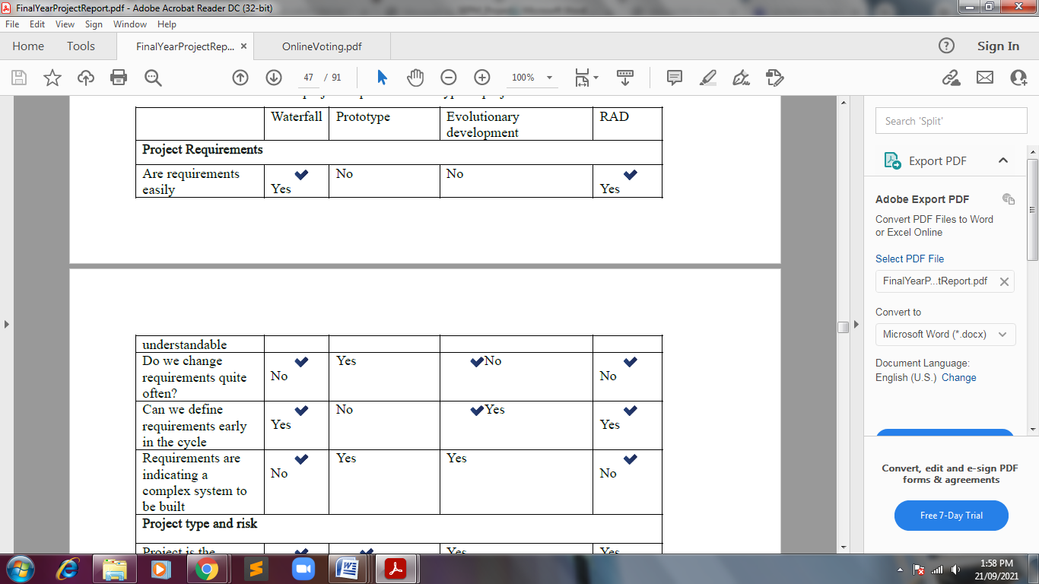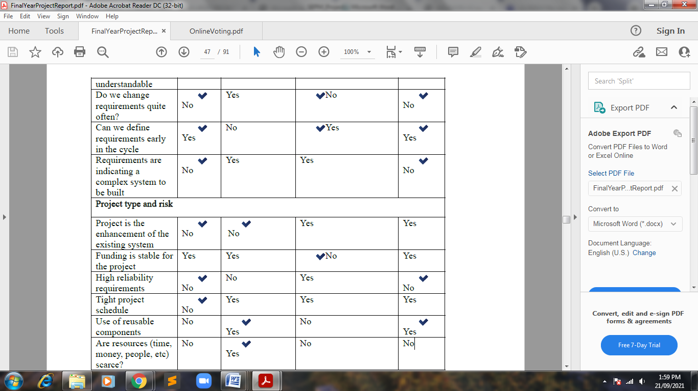

It is noted that the waterfall model satisfies majority of the project requirement and is thus chosen.

**Steps for Waterfall Model:**



Requirements analysis and specification: The first phase involves understanding what needs to design

and what is its function, purpose, etc. Here, the specifications of the input and output or the final

product are studied and marked.

System Design: The requirement specifications from the first phase are studied in this phase and

system design is prepared. System Design helps in specifying hardware and system requirements and

also helps in defining overall system architecture.

Implementation and Testing: With inputs from system design, the system is developed and constructed

and tested.

Integration and System Testing: The system is deployed and tested in the environment of operation.

Operation and Maintenance: This step occurs after installation, and involves making modifications to

the system or an individual component to alter attributes or improve performance.

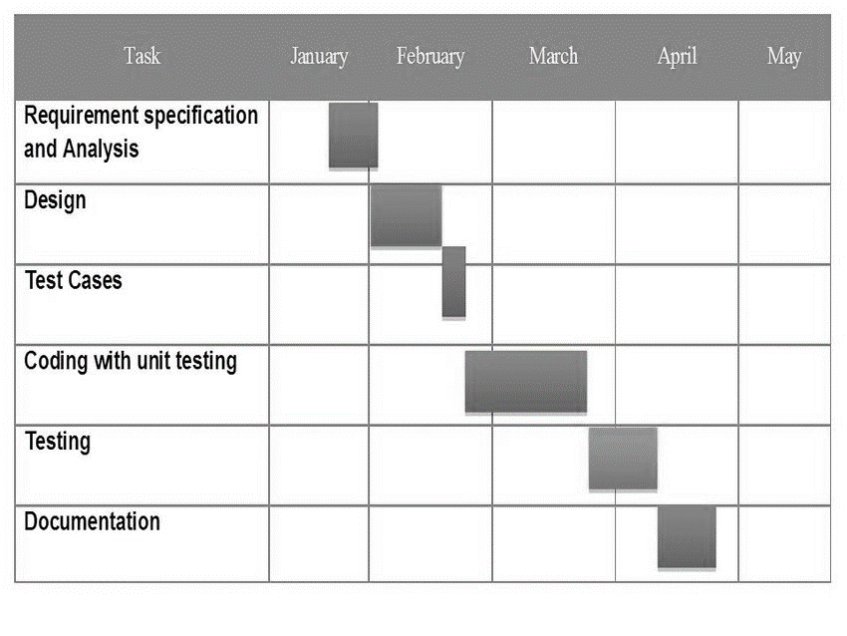

**FUTURE SCOPE AND ENHANCEMENT**

The Online Voting System platform can be made more secure by using the following methods

* Password Changing
* Fingerprinting
* Cornea Detection

The password used by the user to vote is provided by the administrator. In the future the user can be given the privilege of changing the password. So it helps to increase the security of the system. The other two methods that can be used are cornea detection and fingerprinting. But here the problem is that it decreases the scope of the platform because these systems need some electronic components to implement. So it will avoid the user’s privilege to cast the votes at their fingertips. But it can guarantee that fake voting will be nearly not possible.

 Future systems based on secure hardware could provide additional security, but the technology is still in early development. End-to-end verifiable election software relies on cryptography to encrypt and protect votes while allowing voters to see their vote was properly recorded, that the vote was correctly tabulated, and that the final vote count matches the cast votes. End-to-end verifiable software can be integrated into existing election systems to enhance the security of voting infrastructure. Recent open-source software packages including end-to-end verifiability systems, such as Microsoft’s software development kit Election Guard, could increase security if implemented in future.

Online voting presents numerous vulnerabilities and is fundamentally insecure. There is potential for unobserved vote manipulation as well additional security vulnerabilities including potential denial of service attacks, malware intrusions, and privacy concerns.  Online voting does not produce a paper trail for auditing.

Block chain-based voting; which relies on a decentralized, distributed digital ledger is vulnerable to many of the security flaws inherent in internet voting, such as the potential for malware to alter votes on a voter’s local device before the ballot is transmitted and the lack of secret ballots. Online and block chain-based voting would greatly increase the risk of undetectable, nation-scale election failures.

**Experiment: 03**

**Aim:** Perform the function-oriented diagram: DFD and Structured chart

**Theory:**

A **Data Flow Diagram (DFD)** is a traditional visual representation of the information flows within a system. A neat and clear DFD can depict the right amount of the system requirement graphically. It can be manual, automated, or a combination of both.

It shows how data enters and leaves the system, what changes the information, and where data is stored.

**Structure Chart** represent hierarchical structure of modules. It breaks down the entire system into lowest functional modules, describe functions and sub-functions of each module of a system to a greater detail. Structure Chart partitions the system into black boxes (functionality of the system is known to the users but inner details are unknown). Inputs are given to the black boxes and appropriate outputs are generated.

**Diagram:**

**DFD-0**

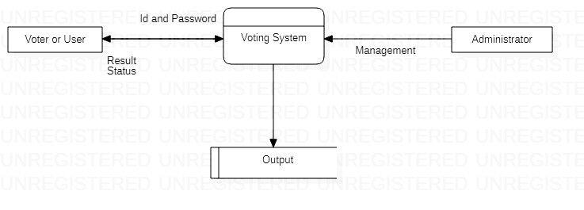

The above diagram is a 0-level DFD that only shows the flow of data between the various and the system. In online voting system the Administrator is the controller of the system and all the decisions are made by him. The Administrator can handle the entire voter and their details, voting details etc. and view details of them and he can update that detail also.

**DFD-1**

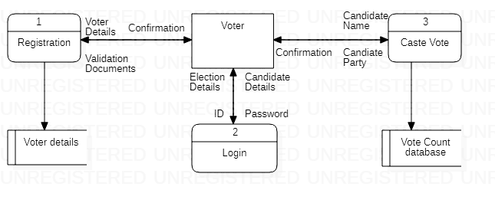

In 1-level DFD, a context diagram is decomposed into multiple bubbles/processes. In this level, we highlight the main objectives of the system and breakdown the high-level process of 0-level DFD into subprocesses.

**DFD-2**

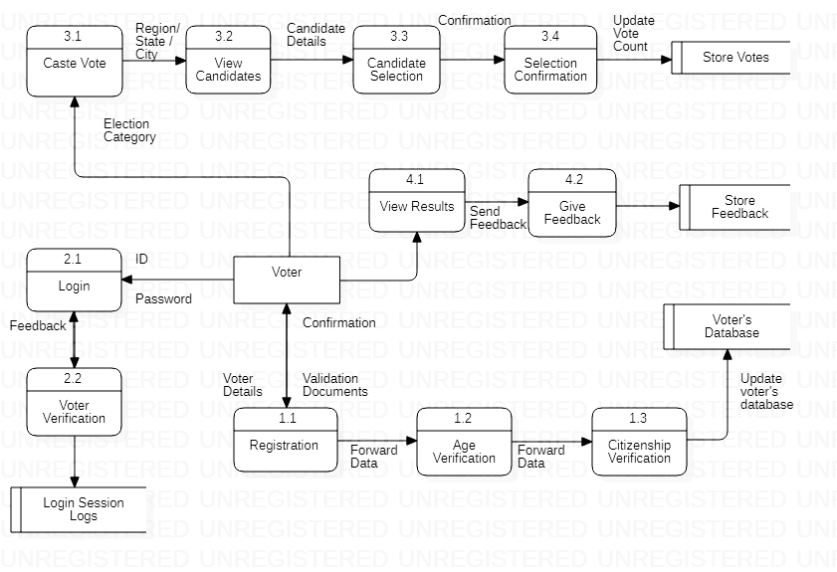

2-level DFD goes one process deeper into parts of 1-level DFD. It can be used to project or record the specific/necessary detail about the system's functioning.

**Structure Chart**

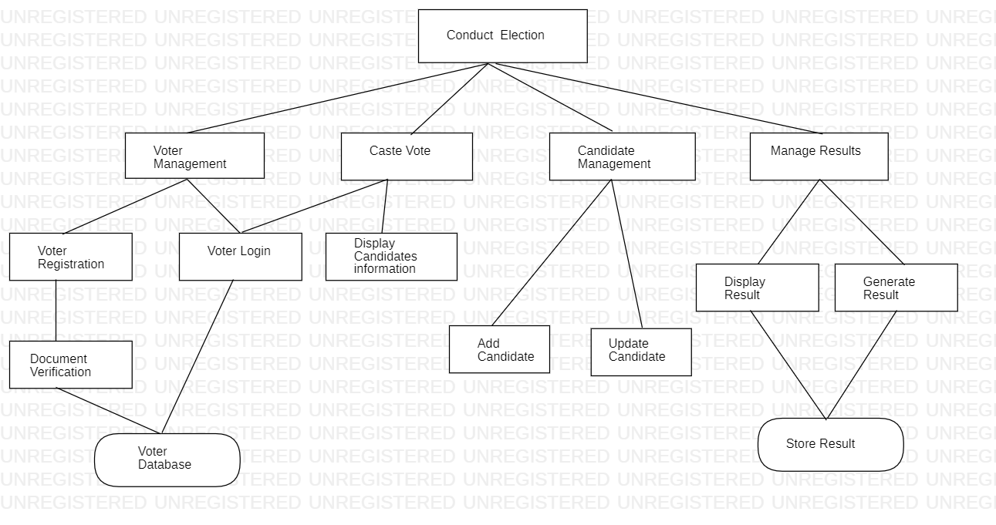

**Experiment: 04**

**Aim:** Perform the user’s view analysis: Use case diagram.

**Theory:**

A use case diagram is used to represent the dynamic behavior of a system. It encapsulates the system's functionality by incorporating use cases, actors, and their relationships. It models the tasks, services, and functions required by a system/subsystem of an application. It depicts the high-level functionality of a system and also tells how the user handles a system.

**Diagram:**

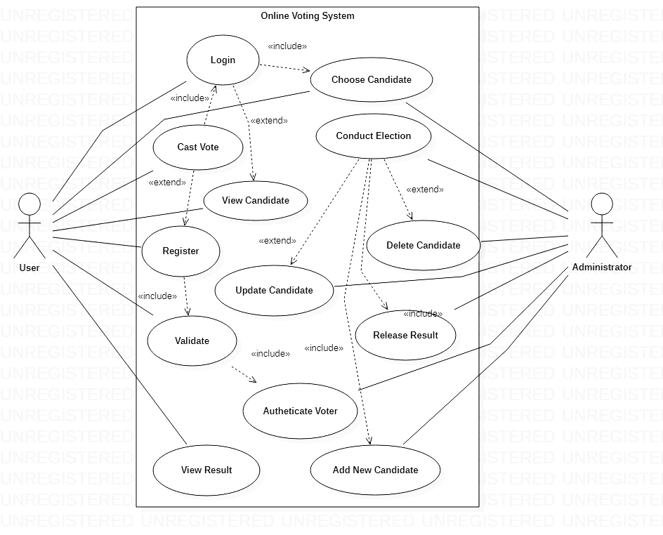

**Experiment: 05**

**Aim:** Draw the structural view diagram: Class diagram, object diagram.

**Theory:**

The class diagram depicts a static view of an application. It represents the types of objects residing in the system and the relationships between them. A class consists of its objects, and also it may inherit from other classes. A class diagram is used to visualize, describe, document various different aspects of the system, and also construct executable software code.

It shows the attributes, classes, functions, and relationships to give an overview of the software system. It constitutes class names, attributes, and functions in a separate compartment that helps in software development. Since it is a collection of classes, interfaces, associations, collaborations, and constraints, it is termed as a structural diagram.

**Diagram:**

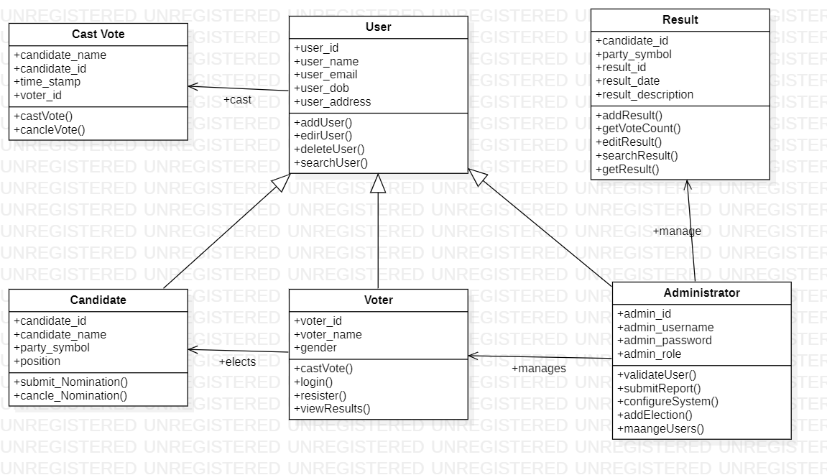

**Experiment: 06**

**Aim:** Draw the behavioral view diagram: Sequence diagram, Collaboration diagram.

**Theory:**

The **sequence diagram** represents the flow of messages in the system and is also termed as an event diagram. It helps in envisioning several dynamic scenarios. It portrays the communication between any two lifelines as a time-ordered sequence of events, such that these lifelines took part at the run time. In UML, the lifeline is represented by a vertical bar, whereas the message flow is represented by a vertical dotted line that extends across the bottom of the page. It incorporates the iterations as well as branching.

**Diagram:**

**Sequence Diagram**

Registration

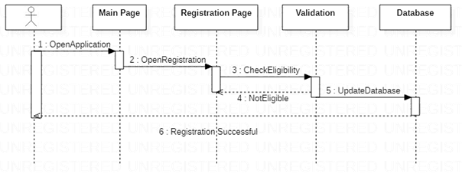

Caste Vote

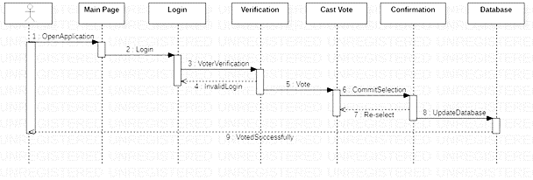

**Collaboration Diagram**

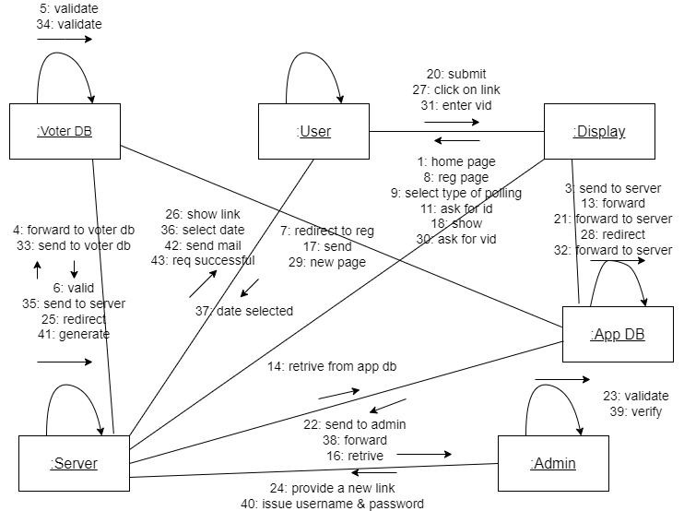

**Experiment: 07**

**Aim:** Draw the behavioral view diagram: State-chart diagram, Activity diagram.

**Theory:**

The **state machine diagram** is also called the **Statechart** or **State Transition diagram**, which shows the order of states underwent by an object within the system. It captures the software system's behavior. It models the behavior of a class, a subsystem, a package, and a complete system.

Following are the notations of a state machine diagram enlisted below:

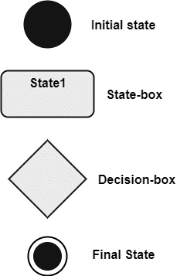

The **activity diagram** helps in envisioning the workflow from one activity to another. It put emphasis on the condition of flow and the order in which it occurs. The flow can be sequential, branched, or concurrent, and to deal with such kinds of flows, the activity diagram has come up with a fork, join, etc.

**Diagram:**

**State-chart Diagram**

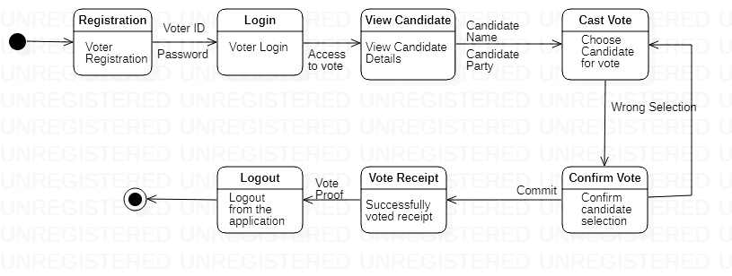

**Activity Diagram**

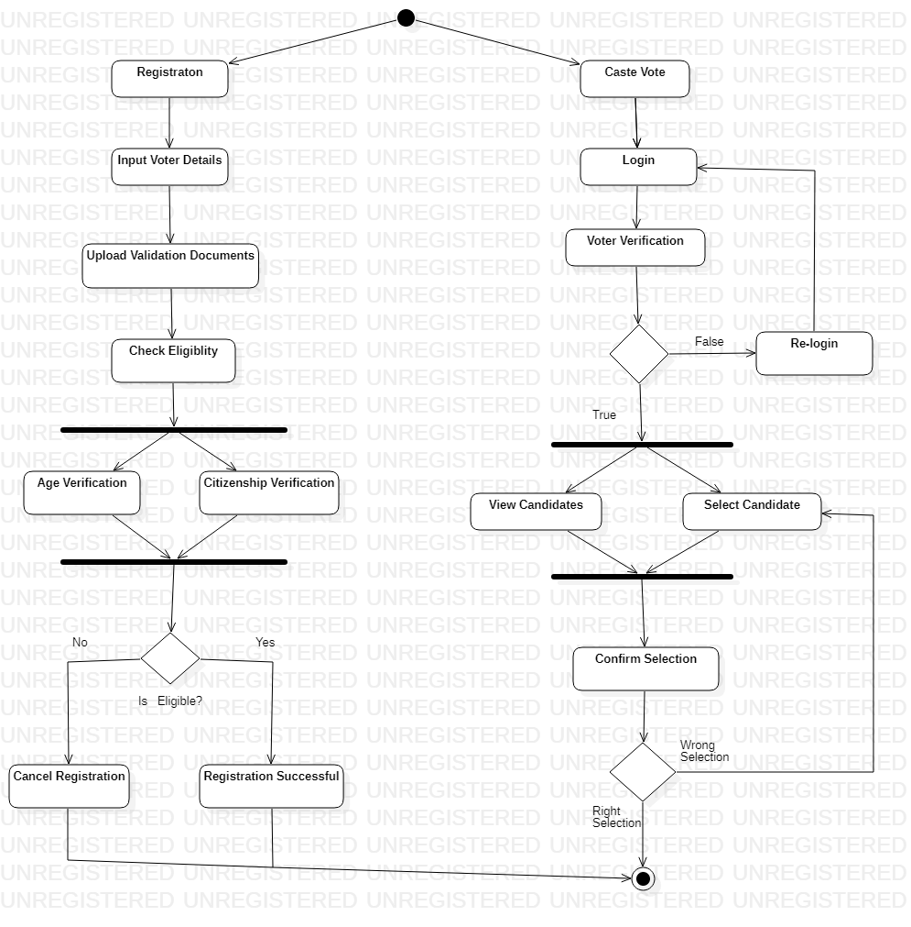

**Experiment: 08**

**Aim:** Draw the implementation view diagram: Component diagram.

**Theory:**

A **component diagram** is used to break down a large object-oriented system into the smaller components, so as to make them more manageable. It models the physical view of a system such as executables, files, libraries, etc. that resides within the node.

It visualizes the relationships as well as the organization between the components present in the system. It helps in forming an executable system. A component is a single unit of the system, which is replaceable and executable. The implementation details of a component are hidden, and it necessitates an interface to execute a function. It is like a black box whose behavior is explained by the provided and required interfaces.

**Diagram:**

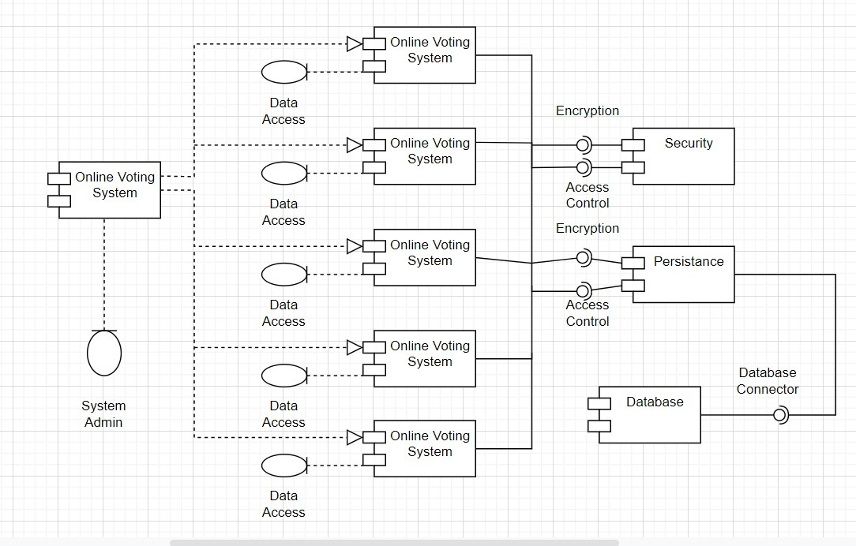

**Experiment: 09**

**Aim:** Draw the environmental view diagram: Deployment diagram.

**Theory:**

**Deployment Diagram** is a type of diagram that specifies the physical hardware on which the software system will execute. It also determines how the software is deployed on the underlying hardware. It maps software pieces of a system to the device that are going to execute it.

The deployment diagram maps the software architecture created in design to the physical system architecture that executes it. In distributed systems, it models the distribution of the software across the physical nodes.

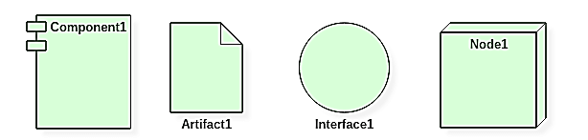

Dependency and association in one of three ways:

1. To model embedded system.
2. To model client and server system.
3. To model fully distributed system.

Nodes:

Node is another name for an object in the model hierarchy. Nodes are displayed in the browser window. Each node has properties, which are displayed in the property view window when the node is selected in the browser.

Examples of nodes are classes, use cases, objects, operations, components, and diagrams.

Processors:

A processor is a hardware component capable of executing programs. Each processor must have a name. There are no constraints on the processor name because processors denote hardware rather than software entities.

It can be represented by the symbol

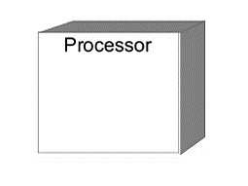

Devices:

A device is a hardware component with no computing power. Each device must have a name. Device names can be generic, such as modem or terminal.

It can be represented by the symbol

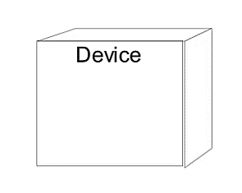

Connections:

A connection represents some type of hardware coupling between two entities. An entity is either a processor or a device. The hardware coupling can be direct, such as an RS232 cable, or indirect, such as satellite-to-ground communication. Connections are usually bi-directional.

Deployment Diagram for online national polling:

**Diagram:**

